jjjjjjjjj
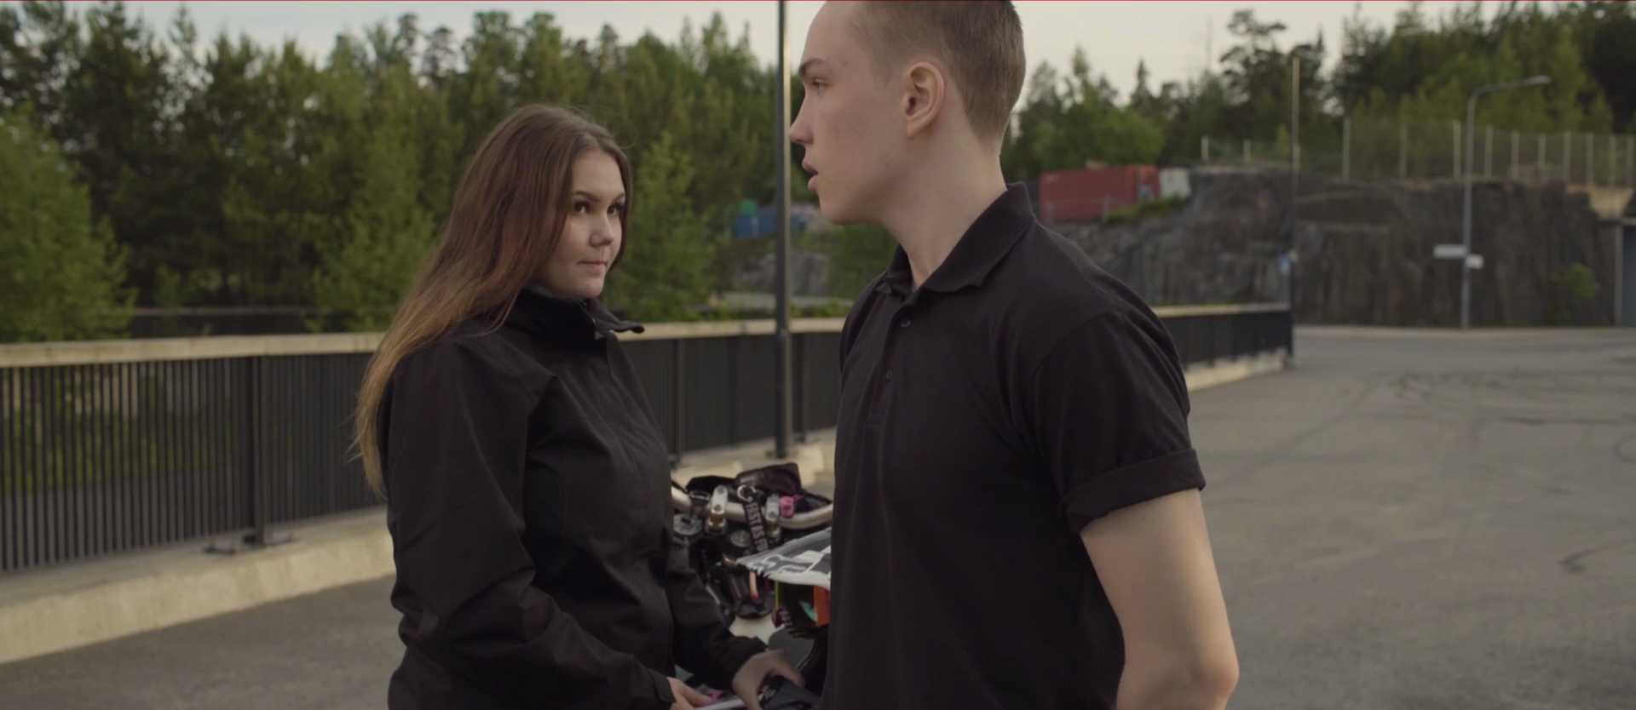
3,000 km to Rome short film
about the lives of young people, made by young people for 9th graders and upper secondary school students
Guide to instructing themed lessons
PKS-mopotoiminta

Contents

1. BACKGROUND AND INTRODUCTION 3
2. TOPICS OF THE THEMED LESSON 4
3. CHARACTERS 5
4. TIPS TO THE INSTRUCTOR 6
5. INITIAL DISCUSSION AFTER VIEWING THE FILM 6
6. BEFORE THE PARTY 7
7. AT THE PARTY 7
8. AFTER THE PARTY 8
8.1 On the straight 8
8.2 At the harbour 8
8.3 Chase 9
8.4 Accident 9
9. SAFETY RISKS 10

BACKGROUND AND INTRODUCTION

Great to see you involved as an instructor of the ‘3,000 km to Rome’ themed lesson.
The short film that depicts the life of young people is a part of the themed lesson package that, with the help of a youth worker, steers 9th-graders and upper secondary school students towards discussing traffic behaviour, substance abuse, the importance of personal choices, and friendly and romantic relationships. The discussion portion can address one or more themes.
The 3,000 km to Rome themed lesson is a follow-up to Pääkaupunkiseudun mopotoiminta’s (Moped activities in the Helsinki Metropolitan Area) traffic education model, which gained great popularity when it was used in Helsinki’s secondary schools in 2014–2016. Several hundred lessons were held and thousands of young people attended.
Pääkaupunkiseudun mopotoiminta and young people have collaborated to make a film that supports traffic and substance abuse education in schools. The film took a whole year to produce, involving young people in the writing, directing, acting, filming and other necessary roles.
The content of the themed lesson has been prepared in cooperation by Pääkaupunkiseudun mopotoiminta and the Klaari Helsinki unit for preventive substance abuse work among young people.
The film is not intended for public distribution. It may only be shown in connection to the 3,000 km to Rome themed lesson.

The minimum duration of the themed lesson is 45 minutes
- Brief introduction (5 min)
- Watching the film (20 min)
- Joint discussion (20 min)

Goals
- To strengthen young people’s understanding of the effects of substance abuse, peer pressure and the consequences of their own choices.
- To influence young people’s attitudes towards traffic behaviour, substance abuse and relationships.
- To encourage young people to make safe choices.
- To consider respectful treatment both in traffic and in friendly and romantic relationships.

Checklist for instructing the lesson
- Strive to create an unhurried and calm atmosphere.
- Admit if you do not know about something. You can always find out and return to the matter later or ask the pupils, in case they know.
- The safety risks presented by the film have been compiled in a separate section (Chapter 9).
- It is the instructor’s task to ensure peace and quiet during the activities.
- Every group discussion is unique!

TOPICS OF THE THEMED LESSON

TRAFFIC SAFETY
Goal: To gain information about traffic safety, traffic legislation and first aid.

SUBSTANCE ABUSE
Goal: To gain information about the alcohol legislation and increase understanding about the impacts of intoxicants on young people and their behaviour/choices.

PEER PRESSURE
Goal: To consider the repercussions of one’s own choices and reinforce safe choices.

FRIENDLY AND ROMANTIC RELATIONSHIPS
Goal: To consider respectful treatment in both friendly and romantic relationships. To step into other people’s shoes and consider the emotions of others.

CHARACTERS

Characters in the story
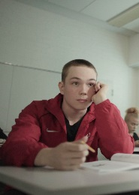 Julia's boyfriend – Elias
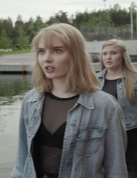 Elias’ girlfriend – Julia
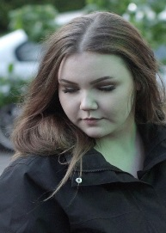 Biker girl – Sofia
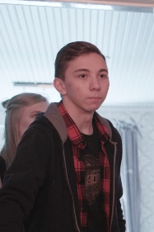 Driver – Julius “Julle”
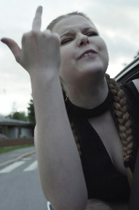 Julia’s friend, girl in the back seat – Nanna
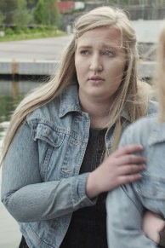 Julia’s friend, girl in the front seat – Eevi

TIPS TO THE INSTRUCTOR

The beginning of the themed lesson is important. Every instructor has their own style of getting started. However, please bear the following in mind:
- Introduce yourself briefly.
- Specify that you will first be watching the short film (about 22 min), which will be followed by joined discussion.
- Indicate that the final scene of the film is affecting and may spark a variety of thoughts and emotions. Remind the pupils that they can always turn to an adult if they have questions or thoughts about the film.
- Encourage young people to openly talk about their thoughts and opinions.
- The discussion portion starts with the kinds of topics/themes that the young people bring up. The themes are listed in Chapter 2. Chapter 5 provides suggestions on topics to open the discussion after the film.
- Listen to what the pupils have to say and address their consideration.

The topics of the film can be addressed through discussion in groups and pairs
- in accordance with the timeline of the story (Chapters 5–8 in this guide)
- through the characters (placing oneself in their position, Chapter 3)
- freely, without adhering to the chronological sequence of events
- The following themes run through the entire film:
  - friendly and romantic relationships
  - peer pressure
  - substance abuse
  - traffic safety risks
Guide
- The guide is intended to support discussion. Please study it carefully before the lesson. Try to instruct the lesson without the guide.
- The guide features a lot of questions; all of them do not need to be covered. They are intended to assist you.
- Any texts in italics are provided as reminders of the film’s events.

INITIAL DISCUSSION AFTER VIEWING THE FILM

The film will be followed by a discussion about 20 min in length. Depending on the instructor and young people involved, the film can be discussed jointly.
Alternatively, you can ask the young people to discuss the film with the person next to them or in small groups for a short time (about 2–3 min). The participants can also think about the film on their own. After this, a joint discussion is held on the topics brought up.
Examples for starting the joint discussion:
  - Could this story be true?
  - What kinds of thoughts did the film evoke? More often than not, the young people’s thoughts tend to focus on the accident depicted in the film; see Chapter 8.4 Accident and Chapter 9 Safety risks.
  - What led to the accident? Could someone have prevented the accident?
  - What choices did the young people in the film make? How do you find the actions of the film’s main characters?
  - It is a good idea to start the joint conversation by asking questions related to the end of the film first.

BEFORE THE PARTY

This section covers the events at the beginning of the film. The sequence of events begins on the bus as Elias suddenly disembarks upon seeing the biker girl Sofia. Elias is almost run over by a car. The events continue in a classroom where Elias’ girlfriend Julia talks with her friends Nanna and Eevi, occasionally glancing towards Elias. Elias exchanges looks with the biker girl Sofia who sits behind him. The last scene before the party features Elias walking to the swing and messaging with Sofia.

- How did the relationships between the friends appear to you?
- Which characters did you think where dating?
- How was the interaction between Elias and Julia? What kinds of emotions did they show each other?
- Did you notice any traffic violations? Who committed them? Elias starts crossing the street in front of the bus, forcing the car driving beside it to brake suddenly.
- Is it ok to invite other uninvited people to someone else’s party?
Elias sends a WhatsApp message to the biker girl, Sofia, and asks her to the party. Sofia promises to come. The film does not indicate whose home the party was at.

AT THE PARTY

This section covers the events at the house until Elias goes after Sofia the biker girl in Julle’s car and Eevi messages Elias’ girlfriend Julia about the matter.

- Could this be an actual party? Did the party seem real?
- What was the party like?
- What was the atmosphere at the party like?
- How old did the young people seem?
- What to do when a party gets out of hand or uninvited guests arrive?

- How did the relationship of Elias and Julia seem at the party?
- How did Elias behave towards his girlfriend at the party?
- How did the girlfriend behave towards Elias at the party?
- Elias smiles twice over the course of the film. Once in class when the biker girl throws a piece of eraser at him, and the second time when he takes a selfie with his girlfriend, sitting on the sofa at the party. Why does Elias smile in these moments? Is a good photo important? Does a smile or serious expression indicate what a person is feeling or thinking?

- Young people at the party
  - How were intoxicants present at the party?
  - Did alcohol impact behaviour and relationships among the young people? If it did, how?
- Did everyone at the party drink alcohol? Did the biker girl or the driver drink? Elias offers a drink to the biker girl.
- How was the alcohol for the party obtained? Did the young people at the party use other intoxicants? Were there adults at the party?
- Did the parents of the characters know about the party? Should they have known about it?
- How do you say no if you do not want to drink?
- One young person is carried down the stairs. Could others have impacted the person’s drinking? How did friends help the person? What should you do in a similar situation?
- Are parties and alcohol inseparably linked? (What is the purpose of parties?)

- Why did Elias leave the party to go after the biker girl? Elias gets into Julle’s car when Sofia leaves the party on her motorcycle.
- What did the girlfriend’s friend do upon seeing Elias leaving with the biker girl?
She messages the girlfriend telling her that Elias just left in Julle’s car to go after the biker girl.
- To what extent is it all right to intervene in the affairs of friends?
- Did Sofia (the biker girl) know that Elias was dating? Elias says ‘yes’ when the biker girl asks him if he came alone.
Do you need to agree to everything?
Learn how to say NO. You have no obligation to agree to everything. Do not leave a friend alone. Take care of others, in addition to yourself. It is a good idea to consider things beforehand to make it easier to stick to personal decisions when faced with a questionable situation.

AFTER THE PARTY

On the straight

The long straight featured in the film is located in Vuosaari. Young people with motorcycles like to gather there. The biker girl has a helmet-mounted camera; young moped riders often have cameras.

- Why are the young people doing wheelies on the straight?
- Are wheelies legal? (The Road Traffic Act prohibits wheelies.)

At the harbour, Julle (the driver) hands beer from the boot of his car to other young people. The young people pay Julle in cash.
- Are the young people of age?
- What can the repercussions be to an adult for providing alcohol to a minor?
Providing alcohol to a minor is prohibited, even if the provider does not collect a fee. The penalty can be a fine or, in more severe cases, a prison sentence.

At the harbour

The girls arrive when Sofia and Elias are kissing.
- How does Elias’ girlfriend react to seeing Elias and Sofia together?
- How does Elias react to the arrival of Julia and her friends?
- How does Sofia react to the arrival Elias’ girlfriend Julia?
- What do Julia’s friends think about the situation? Was it their business to intervene?
- How do the young people talk amongst themselves?

- Could the situation have been handled differently?
- Did alcohol impact behaviour and verbal interaction between the young people?

The girls leave the harbour area in Julle’s car. Elias and Sofia leave the harbour together.

- Upon leaving the harbour, Sofia closed her helmet but did Elias do the same?
- Was Elias sober/drunk when getting on the motorcycle?

Chase

In addition to the driver, there are three young people in the car, one in front and two in the back. The people in Julle’s car see Elias and Sofia. This sparks the chase. The driver begins the chase due to peer pressure when the girl sitting next to him says “drive” after being egged on by the back seat passengers.

- How did the passengers behave in Julle’s car?
- How did the friends of Elias’ girlfriend Julia console her?
- The girl in the front seat drank from a bottle – did she drink of her own will?
- Why did the girl in the front seat offer a drink to the driver?
- Would the passengers have behaved in the same way when sober?
- Did everyone use a seatbelt?
- Why did the girls urge the driver to continue the chase despite the red light at the intersection? Why did the driver do as the others wished and chased after the pair on the motorcycle?
- Can the passengers in the car affect the driver’s traffic behaviour? How?
- Why did Julle drive recklessly and dangerously?
- Who pressured the driver the most?
- How did the biker girl Sofia feel when the car approached her from behind at high speed? Did she brake? Could Sofia have handled the situation differently?

Accident

The accident occurs when a cyclist wheels a bike onto the crosswalk. Sofia loses control of her motorcycle and veers to the side of the road. The car has enough time to stop, and the cyclist is unharmed.
- Could someone or something have prevented the accident? If so, who/what?
- What could the driver / passengers / motorcyclists / cyclist have done differently?

- What factors led to the accident? The cyclist tries to get across the crosswalk.
- Did speed have an impact on the accident?
- Did alcohol have an impact on the accident?

- How did the car passengers react and behave when the accident occurred?
Everyone reacts in their own way. One asks about what to do now, the other says to drive away and the third suggests calling an ambulance. Eevi, who is in the front seat, calls an ambulance.

- What were the repercussions of the accident?
- Did Elias and Sofia survive the accident? Why and why not?
- Did anyone involved suffer any consequences? What?

- Where Julius or Sofia drunk when driving? Julius does not drink any alcohol during the film. Sofia has a sip of alcohol only once.
- Can you ride as a passenger on a moped or motorcycle when intoxicated? You cannot > make sure that everyone knows this

- How did the cyclist behave in the situation?

- Did something happen to the cyclist?
- Who caused the accident?
- Where did the cyclist go? Why did the cyclist disappear from the scene?
- How should the cyclist have acted? In the film, the cyclist turns back and is not shown afterwards.

- What should you do in the event of an accident? What would you do in the event of a accident, for example?

SAFETY RISKS

The film presents the following safety risks:
- Crossing a road dangerously (Elias starts crossing the street directly in front of the bus, forcing the car driving beside it to brake suddenly.)
- Leaving a helmet unfastened (Elias does not fasten the helmet strap at the harbour.)
- Missing riding boots (Sofia is wearing regular sneakers.)
- Wheelies (The Road Traffic Act prohibits wheelies.)
- Having a passenger on a motorcycle is permitted if the motorcycle is registered for two.
- Using seatbelts in the car (Those in the front seat wear seatbelts, those in the back do not.)
- Running a red light in a car (Julle continues the chase after being pressured by the girls.)
- Dangerous behaviour of the car passengers (Touching the car controls from the back seat; Julia honks the horn and Nanna sticks her head out of the rear window.)
- Minors drinking alcohol (If the person is under 15 years of age, a fine is imposed and a child welfare report is lodged. If the person is under 15 years old, a child welfare report is prepared. However, fines cannot be imposed on anyone under 15 years of age.)
- Providing alcohol to minors (At the harbour, Julle (the driver) hands beer from the boot of his car to other young people. The young people pay Julle in cash.) (Providing alcohol to a minor is prohibited, even if the provider does not collect a fee. The penalty can be a fine or, in more severe cases, a prison sentence.)
---------------------------------------------------------------------------------------------------------------------------------
This guide was prepared in cooperation by the following employees of the City of Helsinki Youth Services:
Matti Saarto, Children’s Traffic Town
Dimitrios Zafiris, Pukinmäki moped hall
Elisa Prepula, preventive substance abuse work for young people, Klaari Helsinki
Teija Tarkkinen, preventive substance abuse work for young people, Klaari Helsinki

